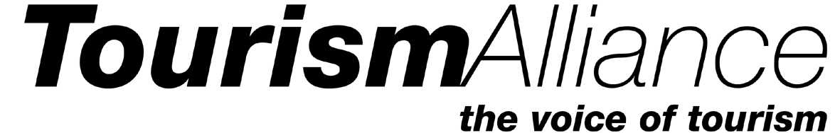

**The Rt Hon Oliver Dowden CBE MP**

**Secretary of State for Digital, Culture, Media and Sport**

**Department for Digital Culture Media and Sport**

**100 Parliament St**

**Westminster**

**London SW1A 2BQ**

**27th October 2020**

**Dear Secretary of State**

**Eligibility for Business Grants**

First, I would like to thank the Government for addressing the impacts facing the UK tourism industry as a result of the Coronavirus epidemic by amending the Job Support Scheme and providing cash grants of up to £2,100 per month for businesses in the hospitality, accommodation and leisure sector adversely impacted by the restrictions in high-alert level areas.

The recognition of the size and importance of tourism to the UK economy is extremely welcome and we believe that tourism will be one of the keys to recovery - as was shown in the wake of the Global Financial crisis when ONS research found that a third of all new jobs in the UK between 2010 and 2013 were in tourism-related businesses.

As you will be aware, tourism incorporates a wide range of diverse but inter-related businesses that depend on each other for survival; from tour operators and travel agents, transport operators, accommodation providers, attractions and activities, conferences and event organisers, through to restaurants and pubs. It is, in effect, an ecosystem of businesses where each component depends on the other for its survival and to generate the £31.5bn per annum in overseas earnings that tourism provides for the UK economy.

The reason for writing is to ensure that the eligibility criteria of new Business Grants announced by the Chancellor recognises the interconnected nature of businesses in the tourism industry by being available to all tourism businesses.

This issue arose in March when the Chancellor announced the Government’s first support package for hospitality and leisure businesses. When he made the announcement, he stated that the support would be available to every single business in the sector:

*“* ***every single shop, pub, theatre, music venue and restaurant, and any other business in the retail, hospitality or leisure sector, will pay no business rates whatsoever for 12 months, and if they have a rateable value of less than £51,000, they will now get a cash grant as well.****”*

However, when it came to implementing this policy, arbitrary eligibility criteria were included in the guidance that resulted in a number of important components of the UK’s tourism and leisure industry missing out on this support, including:

* Tour Operators and Travel Agents
* Coach Operators
* Language Schools
* Destination Management Organisations
* Conference and Events Organisers

These are some of sectors of the tourism industry that have been hardest hit by international travel restrictions and the requirement for visitors from most countries to undergo quarantine. They are also severely impacted by the introduction of the three tier Covid alert system which has limited the ability of these businesses to move groups from one area of the UK to another.

As a result, many of the businesses in these vital export sectors are in desperate need of financial support to survive and lead the recovery when international travel returns.

Because of their importance to the recovery of the tourism and leisure industry as a whole, and the extreme financial difficulties that they are facing, we are therefore asking you to ensure that they are eligible to apply for the new business grants.

Should you require any further information or wish to discuss this issue, please do not hesitant to contact us.

.



Kurt Janson

# Director

cc. Nigel Huddleston MP, Minister for Sport, Tourism and Heritage